**BCTOWNHALLS2024** (VICTORIA)

(COMMUNITY ENGAGEMENT REPORT)

05

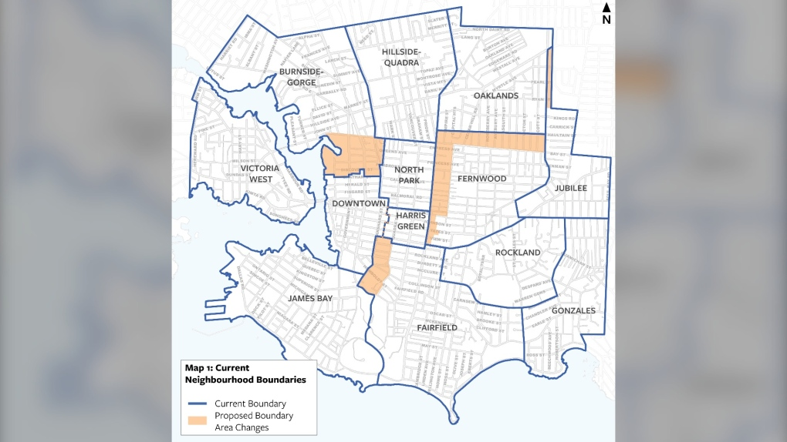VICTORIA NEIGHBOURHOODS

CENTRAL SAANICH NEIGHBOURHOODS

BCTH24 -VICTORIA- CEF-05 COM ENG SAAN-VIC NEIGHBOURHOOD MAP