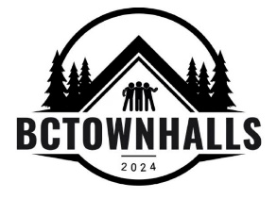 | Contribution Envelope (cash / eTransfer / credit card)  Tonight's Citizen Townhall meeting is run by volunteers on a non-profit basis.  Funds are managed by Dr. Ingrid Pincott and used to pay for tonight's room rental and its audio visual system, plus the lawn signs and other promotional costs.  It's completely non-profit. No income tax receipts will be issued.  Any leftover funds will be forwarded to the next Townhall meeting in Campbell River or a nearby community.  Name ___________________________________________________________  Email (please print clearly)  Phone _____________________________  Contributions may also be eTransfered to townhallcr@gmail.com
bctownhalls2024.ca
778-560-4444

